TOURIST GUIDE FOR STUROVO IN SLOVAKIA

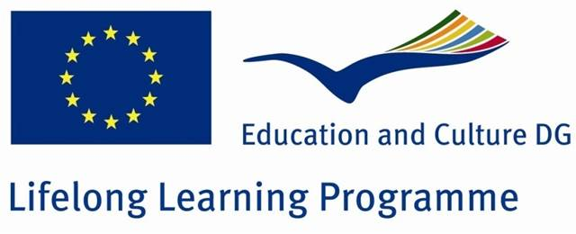

Prepared by the students of Meryem Mehmet Kayhan Primary School in Adana, Turkey
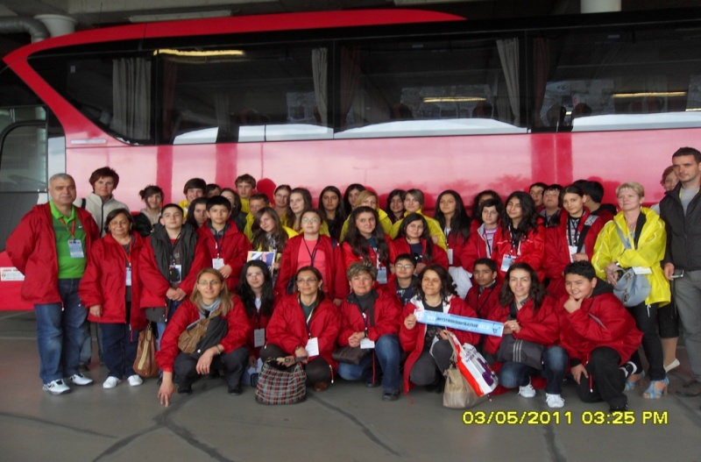

IF YOU GO TO STUROVO, YOU WILL FEEL YOURSELF AT HOME

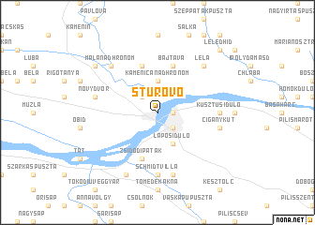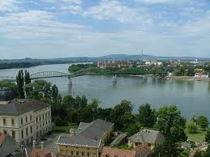
Štúrovo is situated on the left bank of the Danube river at the Slovak-Hungarian border. Štúrovo is the southern most city in Slovakia attracting a lot of visitors with its interesting countryside. The Bend of the Danube river starts here with a splendid view of the Basilica in Esztergom, Hungary.
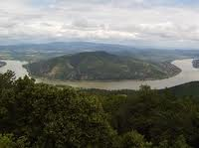
The town is surrounded by the Kováčovske Hills, the highest of which is the Burda with maximum height of 395 m above sea level.

The History of the Town
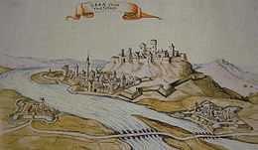Párkány and Esztergom in 1664
Until 1948, the town was known as Parkan in Slovak. It was given its current name after World War II and is named after the 19th century Slovak national leader, Ľudovít Štúr.

Maria-Valeria Bridge
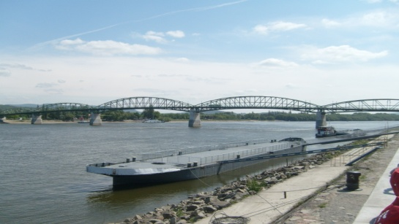
This bridge is one of the most
important tourist attraction
in Sturovo. The International
bridge between Esztergom and
Sturovo gives you an opportunity to look at the great Basilica of Esztergom and you have a look into Slovakia.

The Mária Valéria bridge connects the settlements. The bridge was destroyed in 1944 during World War II, but reconstructed in 2001. The Mária Valéria bridge joins Esztergom in Hungary and Štúrovo in Slovakia, across the River Danube.
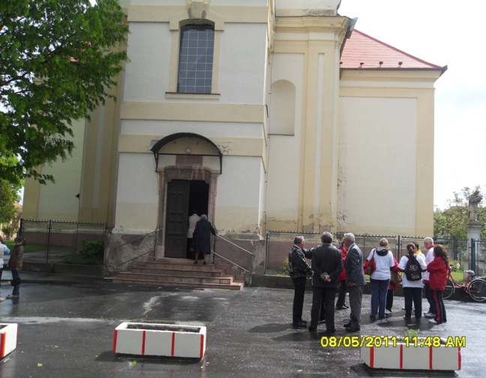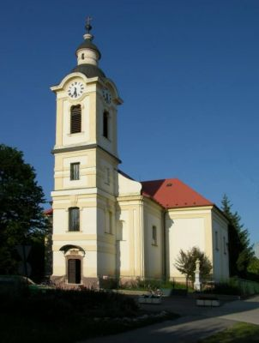
CHURCH OF SAINT IMRICH, STUROVO
The only protected sightseeing of the town was built in the 18th century in the baroque style. Next to the church there is a baroque Calvary from 1766, which is also a protected monument. The church is open daily from 5:00 p.m. on weekdays and from 9:00 a.m. at the weekend during the holy mass.
The Russian Cemetery

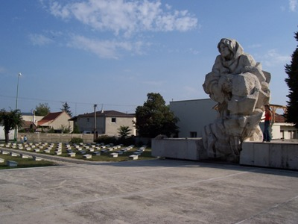 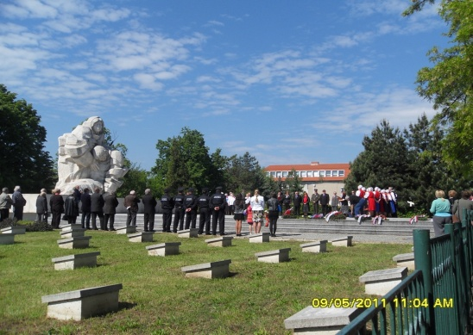 In the center of this city, next to the Roman-Catholic cemetery, is a war cemetery for 5.200 Soviet soldiers and officers who fell in 1945. The cemetery contains mass graves as well as individual graves

SPORTS IN STUROVO
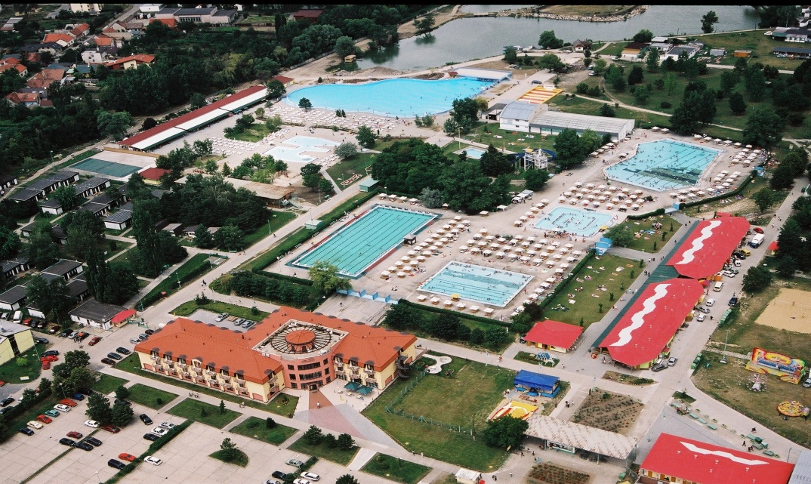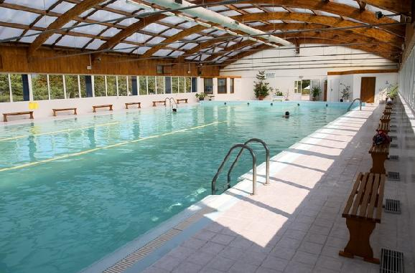
Štúrovo is a spa town. The Thermal Spa VADAŠ is justly famous not only in Slovakia but also abroad. It has a capacity for 8.500 visitors and with its reconstructed pools of different sizes, indoor swimming pool, reconstructed row of snack-bars/cafeterias, sanitary and sport facilities,
CULTURAL LIFE
There are lots of nice places to spend your time. You can visit some museums like Town museum, The Exhibition of regional history, The ethnographic exhibition or old cars museum. If you don’t want to visit museums, you can walk or ride a bicycle and do shopping in the city center.
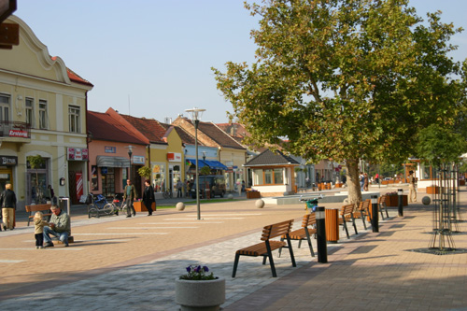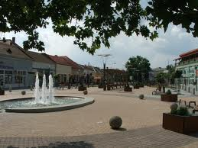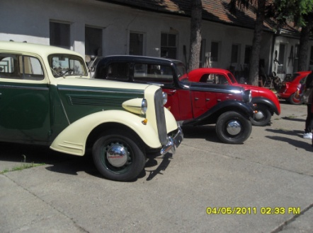
Organized Events in the Town
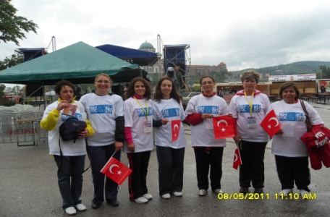
There are some nice organized events in
Sturovo. Beer Festival, Summer Welcome,
Spring Days, Autumn Days and Europen Day. During these festivals, many concerts and cultural events are being organized. People have fun.

Accommodation
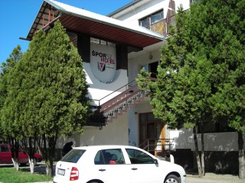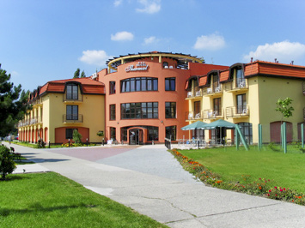
There is a wide range of accommodation in Sturovo. Visitors can choose one of them. They are three-star hotels, apartments lux, bungalows, wooden huts, tourist hostels and autocamping.
Food
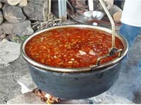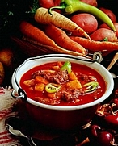 Gulash Soup (Gulášová polievka) It is a traditional soup in Sturovo. It is very delicious. When you go to Sturovo, you must taste it.
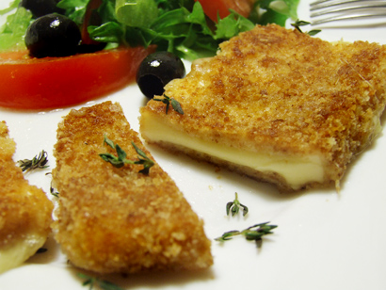 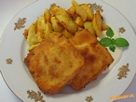 Vyprážaný syr (Slovak Fried Cheese)
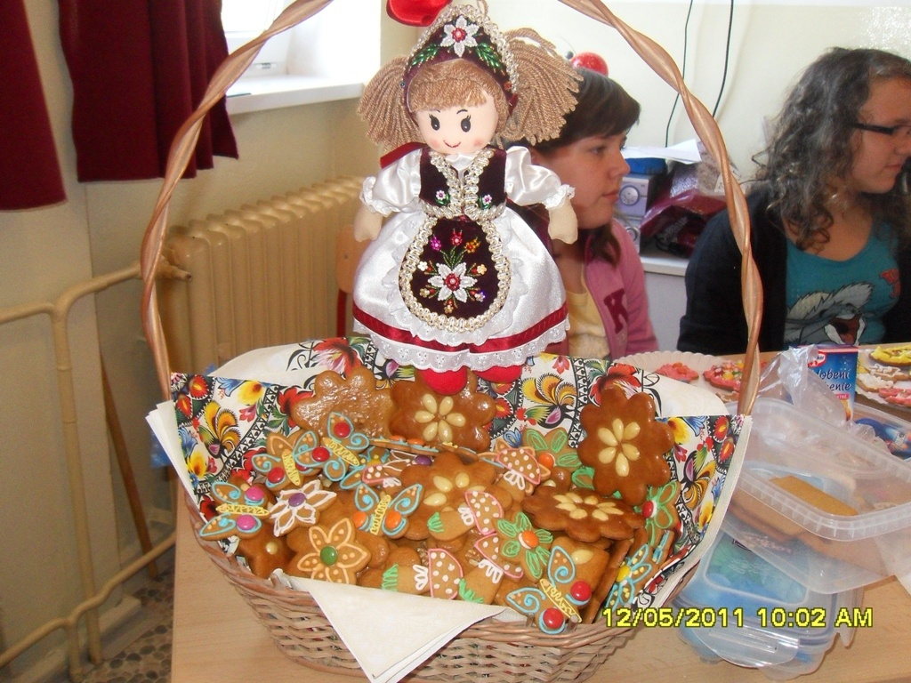 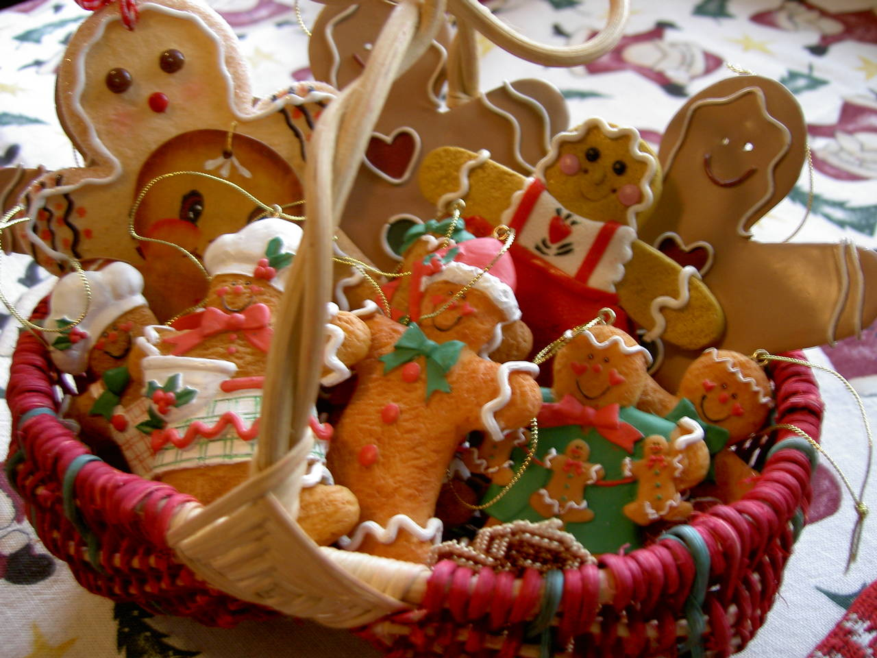 Ginger Bread.
It looks very nice, isn’t it?

